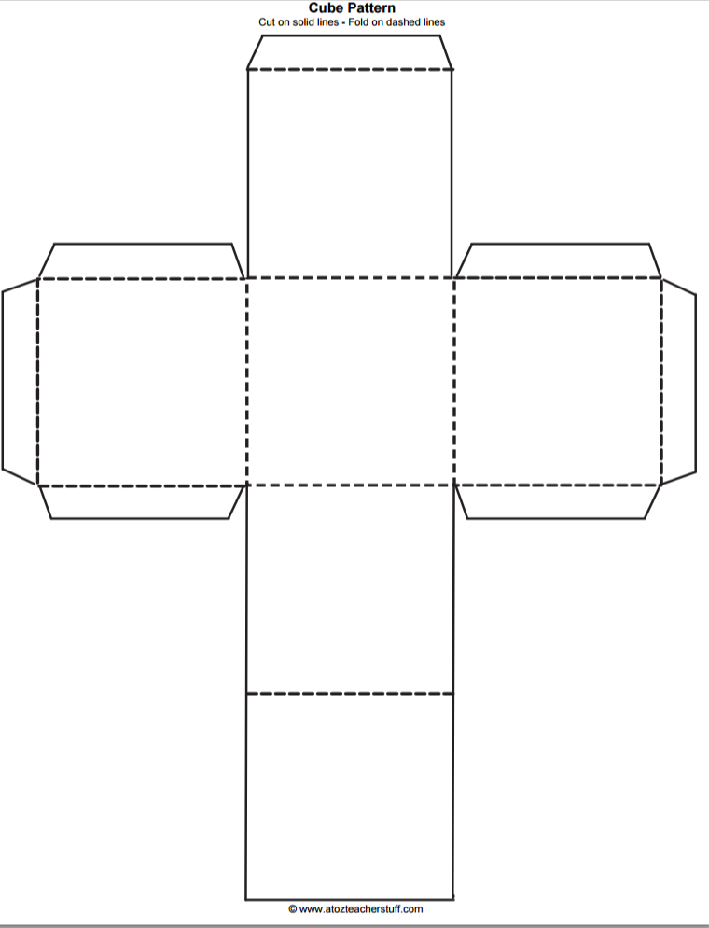
Exit Ticket:

Inferring is explaining or interpreting an observation. When you make an inference you combine what you observed with your prior knowledge and experience. There can be more than one inference for the same observation. Therefore each inference may not necessarily be correct.

Make at least two inferences based upon this observation:

You observe that the ice cream in the freezer is melted.
Inference #1:
________________________________________________________________________________________________________________________________________________________________
Inference #2
______________________________________________________________________________
________________________________________________________________________________

